Thermal Desalination; A Missing Link in LA’s Water Energy Nexus?
William B. DeOreo, M.S., P.E., Aquacraft, Inc.

On an average day the City of Los Angeles water plants deliver approximately 480 MGD of treated water for the citizens it serves. Virtually all of this water is imported into the LA basin from sources such as the Colorado River, the Owens Valley and the State Water Project. The delivery and treatment of water from each of these sources has its own impacts on the environment and the energy requirements of the system. It takes energy to collect, treat and deliver water.

At the same time the LADWP operates at least 7 power plants in the LA Basin with a combined electrical generating capacity of approximately 7000 MW. Currently these power plants all are confronting the need to find ways to cool themselves in a way that does not include once through cooling with ocean water. Some of them are actually slated for retirement in order to avoid having to deal with this problem, and others are slated to switch over to air cooling, a system that uses large amounts of energy and is far less efficient than water cooling.

All of this is occurring when California is in the midst of an epic drought which is forcing the curtailment of water use throughout the state, and causing immense economic losses. There is simply not enough water in the traditional sources of Los Angeles water supply to meet current uses, and storage in reservoirs, including groundwater, is declining at an alarming rate.

I would like to suggest that the solution to both the power plant cooling and the water supply lies right at the feet of the City, in the form of the Pacific Ocean. The system that can integrate the water and power aspects is called “thermal desalination”, not to be confused with reverse osmosis. Like the latter, thermal desalination produces potable fresh water from sea water, but it does so by using the waste heat from power plants to generate fresh water by distillation, and not by using electricity to run pumps as is done in reverse osmosis. This is heat that would otherwise go to waste or require the very once through cooling that needs to be eliminated.

Roughly speaking it is possible to generate 1 million gallons per day of fresh water from each 10 MW of installed electrical generation capacity. If all of the 7000 MW of power production that are currently on-line could be coupled with thermal distillation units this could generate 700 MGD of fresh water for the City (compared to the average daily demand of 480 MGD.) Obviously, there are a lot of details and technical challenges to overcome to realize this potential, but the possibility of creating a totally reliable and locally derived water supply from waste heat should be too enticing to ignore.

There are two main candidates for the types of distillers that would be used for such a large scale system: multiple stage or multiple effect distillation units. These systems have not been used in the United States, but they are well understood and have been used on a large scale in places like the Persian Gulf, Saudi Arabia and many Caribbean Islands. They produce high quality water (at 20 ppm salinity) from low quality heat (lower than the boiling point of water). There is no reason why the use of these systems should not be given careful consideration by the Department of Water and Power. A schematic of a multiple effect distiller is shown in Figure 1.

Distillation units of this kind are ideally suited to a combined water and power cycle, as shown in Figure 2. In this case a distiller is using the waste heat from a gas turbine generator to produce potable water. Notice that heat from the turbine is used twice for generation of electricity before it enters the distillation unit. The water that leaves the distiller is only slightly warmer than the water that is withdrawn from the ocean. Problems associated with inlets and outlets can be addressed through proper design. These plants can also be operated with solar and wind energy so that when there is excess energy available from the wind or sun more water is generated and less electricity, which is really a way of storing energy in the form of water.

Given the critical nature of both the water and energy systems in the Los Angeles areas it seems urgent to include all possible solutions, and thermal distillation is a system that has the potential to help solve both the power cooling and the potable water problems. We hope that future water and power studies will include thermal distillation as part of the system. Continuing to rely on imported water (when available) and dealing with chronic water shortages should not be an option when there is such a huge potential source readily available if we will just apply the right technology and keep a cool head.
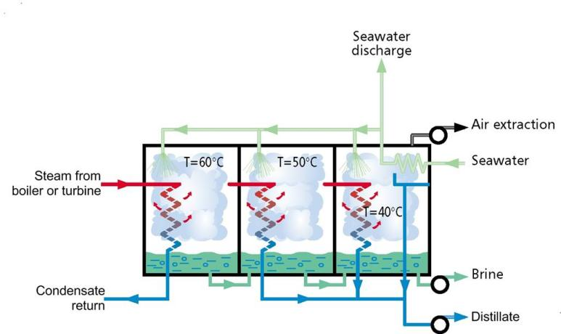
Figure 1: Schematic of a multiple effect distillation unit (source: sidem-desalination.com)

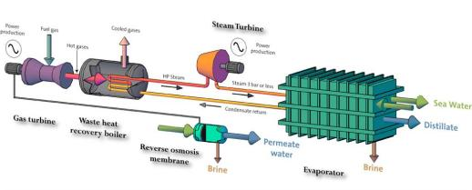
Figure 2: Schematic of a thermal distillation unit attached to the gas turbine electrical plant
(source: sidem-desalination.com)

